The Mercurial Barometer: Measuring Pressure
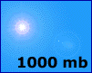
Based on a principle developed by Evangelista Torricelli in 1643, the Mercurial Barometer is an instrument used for measuring the change in atmospheric pressure. It uses a long glass tube, open at one end and closed at the other. Air pressure is measured by observing the height of the column of mercury in the tube. At sea level, air pressure will push on the mercury at the open end and support a column of mercury about 30 inches high. If you used water instead of mercury, you would need a glass tube over 30 feet in length.
As atmospheric pressure increases, the mercury is forced from the reservoir by the increasing air pressure and the column of mercury rises; when the atmospheric pressure decreases, the mercury flows back into the reservoir and the column of mercury is lowered.

Control the Weather
To see how weather and pressure are linked, move your mouse over the scale lines on the barometer to the left and observe what happens to the picture above. (JavaScript Required.)

Make Your Own Barometer

Materials Needed:
- Drinking straw (clear plastic).
- Narrow-neck glass bottle.
- A rubber or cork stopper which fits in the neck of the bottle

Instructions
- Insert a drinking straw into the bottle.
- Fill the bottle about half-way full of water.
- Seal the neck of the bottle around the straw either with the rubber stopper or a cork.
- Make sure the end of the straw is immersed in the water and that the water level in the straw is above the top of the bottle.
As the air pressure outside the bottle decreases, the trapped air inside the bottle will push the water up the straw. As the air pressure outside the bottle increases, it will push the water farther down the straw. See Figure 1.
Please Note: You'll need to keep your barometer's temperature constant, since temperature will also affect the water level. Nasa kids
MAKE AN ANEMOMETER 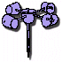
MATERIALS:
- 5 three ounce paper Dixie Cups
- 2 soda straws
- pin
- paper punch
- scissors
- stapler
- sharp pencil with an eraser
PROCESS:
Take four of the Dixie Cups and use the paper punch to punch one hole in each, about a half inch below the rim.
Take the fifth cup and punch four equally spaced holes about a quarter inch below the rim. Then punch a hole in the center of the bottom of the cup.
Take one of the four cups and push a soda straw through the hole. Fold the end of the straw and staple it to the side of the cup across from the hole. Repeat this procedure for another one-hole cup and the second straw.
Slide one cup and straw assembly through two opposite holes in the cup with four holes. Push another one-hole cup onto the end of the straw just pushed through the four-hole cup.
Bend the straw and staple it to the one-hole cup, making certain that the cup faces the opposite direction from the first cup. Repeat this procedure using the other cup and straw assembly and the remaining one-hole cup.
Align the four cups so that their open ends face in the same direction either clockwise or counter-clockwise around the center cup.
Push the straight pin through the two straws where they intersect.
Push the eraser end of the pencil through the bottom hole in the center cup. Push the pin into the end of the pencil eraser as far as it will go.
Now your anemometer is ready for use!
EXPLANATION:
An anemometer is useful because it rotates with the wind. To calculate the velocity at which your anemometer spins, determine the number of revolutions per minute (RPM). Next, calculate the circumference (in feet) of the circle made by the rotating paper cups. Multiply your RPM value by the circumference of the circle and you will have an approximation of the velocity of at which your anemometer spins (in feet per minute). Your anemometer doesn't need to be pointed in the wind for use.
Note: Some forces are being ignored including drag and friction for this elementary illustration, so the velocity at which your anemometer spins is not the same as wind speed.
http://www.weatherwizkids.com/experiments-anemometer.htm

http://www.weatherwizkids.com/weather-experiments.htm

MAKE LIGHTNING IN YOUR MOUTH
MATERIALS:
- Wint-O-Green or Pep-O-Mint lifesavers
- dark room
- mirror
PROCESS:
Go to a really dark room and stand in front of the mirror. Wait a few minutes until your eyes get accustomed to the darkness.
Put a Wint-O-Green or a Pep-O-Mint lifesaver in your mouth.
While keeping your mouth open, break the lifesaver up with your teeth and look for sparks. If you do it right, you should see bluish flashes of light.
EXPLANATION:
Why does this happen? When you break the lifesaver apart, you’re breaking apart sugars inside the candy. The sugars release little electrical charges in the air. These charges attract the oppositely charged nitrogen in the air. When the two meet, they react in a tiny spark that you can see.
http://www.weatherwizkids.com/experiments-lightning-mouth.htm
MAKE YOUR OWN BAROMETER I
MATERIALS:
- small coffee can
- plastic wrap
- scissors
- straw
- index card
- rubber band
PROCESS:
Tightly cover the top of the coffee can with plastic wrap, using a rubber band to hold the plastic wrap in place.
The cover should be tight making the can airtight.
Place the straw horizontally or sideways on the plastic wrap so that two-thirds of the straw is on the can.
Tape the straw to the middle of the plastic wrap so that it will not fall off.
Tape an index card to the can behind the straw. The straw will act as a pointer on the card.
Carefully record the location of the straw on the index card with a pencil. If desired, marks can be drawn on the index card to make observing the changes easier.
After 15 minutes, record the new location of the straw on the index card. Continue checking and recording the straw location as often as you want.
EXPLANATION:
High pressure will make the plastic cave in and the straw go up. Low pressure will make the plastic puff up and the straw go down. If possible, check your measurements with a real barometer.
http://www.weatherwizkids.com/experiments-barometer.htm
BALLOON IN A BOTTLE 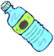
MATERIALS:
- plastic water or pop bottle
- large bowl
- balloon
- ice water
- hot water
PROCESS:
Fill the plastic bottle with hot water.
Swirl the water around to make the bottle hot and then pour it out.
Refill the bottle one-fourth full with hot water and place the balloon over the mouth of the bottle.
Fill the large bowl with ice water and place the bottle in the bowl.
Watch as all of the air is taken from the balloon. It might even get sucked into the bottle.
EXPLANATION:
What happens? The hot air in the bottle expands as the cool air outside the bottle contracts. When you first place the balloon over the mouth of the bottle, the air in the bottle is hot. As the air cools from the ice water outside the bottle it contracts and pushes the balloon into the bottle. This is why the air is taken from the balloon and sometimes gets sucked into the bottle.
http://www.weatherwizkids.com/experiments-balloon-bottle.htm
MAKE A THUNDERSTORM 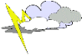
MATERIALS:
- clear, plastic container (size of shoebox)
- red food coloring
- ice cubes made with blue food coloring
PROCESS:
Fill the plastic container two-thirds full with lukewarm water
Let the water sit for one minute.
Place a blue ice cube at one end of the plastic container.
Add three drops of red food coloring to the water at the other end of the plastic container.
Watch what happens.
EXPLANATION:
The blue and cold water sinks while the red and warm water rises. This happens because of convection. The blue water represents the cold air mass and the red water represents the warm, unstable air mass. A thunderstorm is caused by unstable air and convection plays an important part. A body of warm air is forced to rise by an approaching cold front therefore thunderstorm’s form.
http://www.weatherwizkids.com/experiments-make-thunderstorm.htm

EXAMINING COLORS
MATERIALS:
- red, blue and yellow food color (primary colors)
- 1 cup of milk
- dish soap
- shallow and flat bowl or container
PROCESS:
Pour 1 cup of milk into the bowl.
Add 3 drops of red food color to one edge of the bowl.
Add 3 drops of blue food color 1/3 of the way away.
Add 3 drops of the yellow food color 1/3 of the way away.
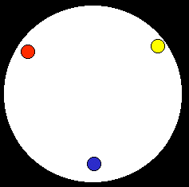
Don't mix of jiggle the bowl.
Squeeze a drop of the dish soap in the center of the bowl.
Watch what happens!
EXPLANATION:
The dish soap does not mix with the milk. Instead, it floats on top and spreads over the surface. As it spreads, it grabs the food color of the primary colors you dropped into it. Where the color meet, the combine and form new colors. We call these colors, secondary colors!
Red + Yellow = Orange
Blue + Red = Purple
Yellow + Blue = Green
http://www.weatherwizkids.com/experiments-rainbow-colors.htm

Make a Tornado in a Bottle

Learn how to make a tornado in a bottle with this fun science experiment for kids. Using easy to find items such as dish washing liquid, water, glitter and a bottle you can make your own mini tornado that’s a lot safer than one you might see on the weather channel. Follow the instructions and enjoy the cool water vortex you create!

What you'll need:
- Water
- A clear plastic bottle with a cap (that won't leak)
- Glitter
- Dish washing liquid

Instructions:
- Fill the plastic bottle with water until it reaches around three quarters full.
- Add a few drops of dish washing liquid.
- Sprinkle in a few pinches of glitter (this will make your tornado easier to see).
- Put the cap on tightly.
- Turn the bottle upside down and hold it by the neck. Quickly spin the bottle in a circular motion for a few seconds, stop and look inside to see if you can see a mini tornado forming in the water. You might need to try it a few times before you get it working properly.

What's happening?
Spinning the bottle in a circular motion creates a water vortex that looks like a mini tornado. The water is rapidly spinning around the center of the vortex due to centripetal force (an inward force directing an object or fluid such as water towards the center of its circular path). Vortexes found in nature include tornadoes, hurricanes and waterspouts (a tornado that forms over water).
http://www.sciencekids.co.nz/experiments/makeatornado.html

Measuring Wind Speed
At one time, sailors would use flags and streamers to measure the strength of the wind. In 1805, Sir Francis Beaufort published his table of wind speeds based on what happened to the sails of a man o'war. With some modifications, his scale is still used today. You can use a flag and the Beaufort wind scale below to find out how fast wind is moving.

Materials
- a printed copy of "Beaufort wind scale #1", below
- a printed copy of "Beaufort wind scale #2", below
- scissors
- sharpened pencil
- brad paper fastener
- colored pencils or crayons

To print this page
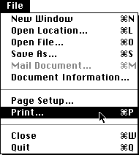
- PLACE the mouse pointer on the File menu at the top of the screen.
- CLICK and HOLD the mouse button down while DRAGGING the pointer to Print.
- RELEASE the mouse button. The print dialog box is displayed.
- PRESS RETURN. The wind scales will begin to print.

Instructions
- CUT OUT each Beaufort wind scale along the outside circle.
- COLOR each Beaufort wind scale if desired.
- CUT OUT both shaded areas on Beaufort wind scale #1.
- With a sharpened pencil, PUNCH a hole through the black dot in the center of each circle.
- PLACE Beaufort wind scale #1 on top of Beaufort wind scale #2.
- PUSH the brad fastener through the center hole of both circles.
- FLIP your Beaufort wind scale over and spread open the fastener.
- SPIN the wheel to make sure it moves freely.
- USE your new Beaufort wind scale to see how fast the outside wind is moving .

http://www.miamisci.org/hurricane/windscale.html

Beaufort wind scale #1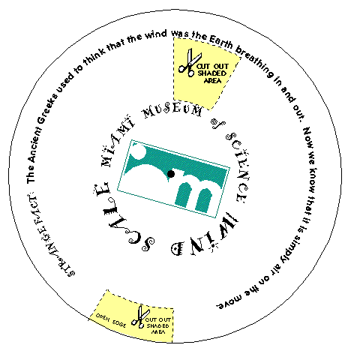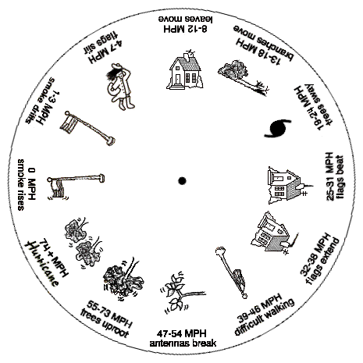Beaufort wind scale #2

